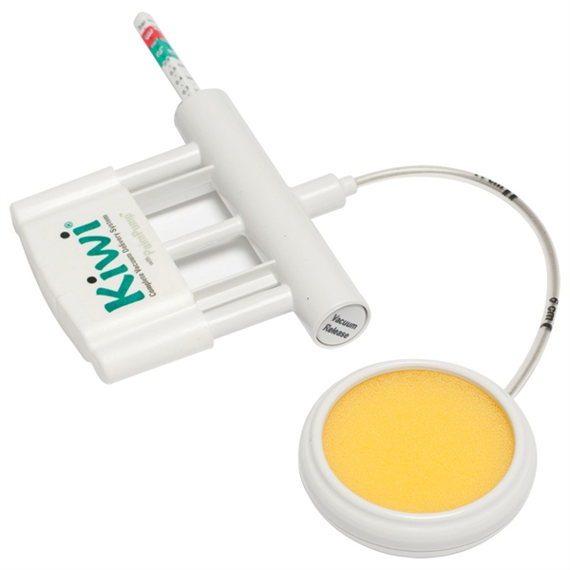**Mulago Hospital protocol for cleaning and sterilizing Kiwi vacuum extractors**

Cleaning of Kiwi vacuum extractors should be done in the instrument processing room.

Wear sterile gloves, protective glasses and a mask.

**Only sterilized Kiwi vacuum extractors can be kept on the labour ward.**

**Used vacuum extractors should go to the instrument processing room.**

**Instrument processing room:**

**Step 1: disinfecting**

After use, keep Kiwi vacuum extractors in a bucket with “JIK” solution for 10 minutes. If the yellow sponge is still present, remove it, by pulling it out.

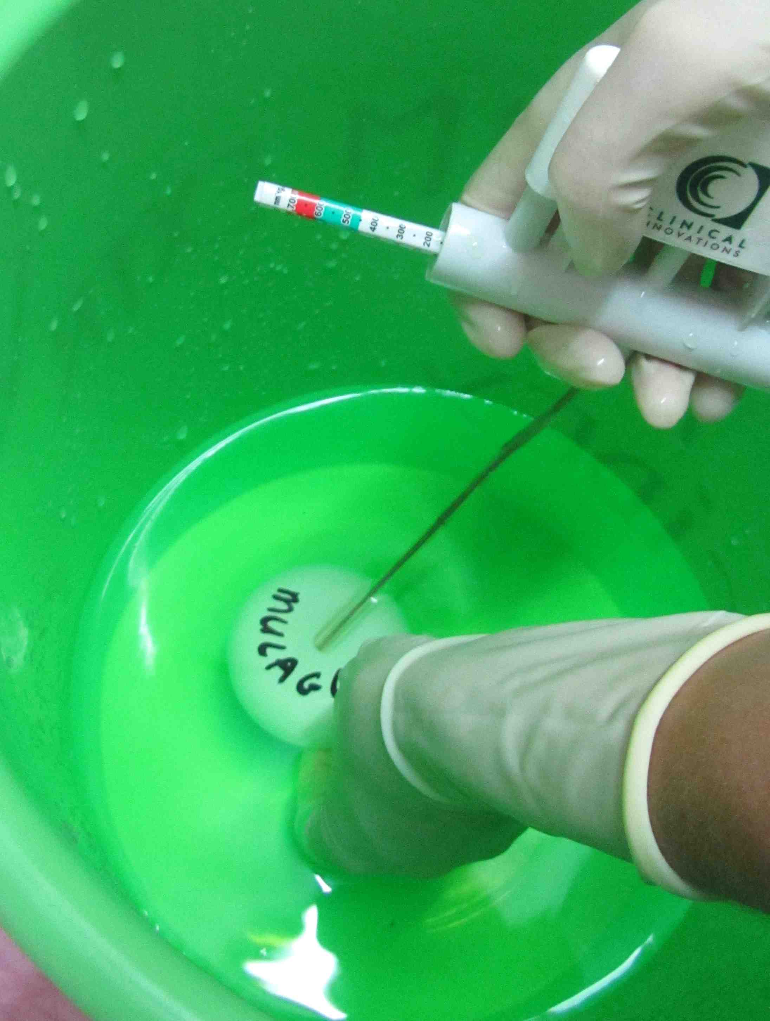 **Step 2: cleaning**

Clean the Kiwi vacuum extractor with soapy water, until no blood is

seen on it.

Pump soapy water through the tube until no blood is seen in the tube

by holding the round part (“cup”) under water while pumping.

**Step** **3: sterilizing**

Sterilize the Kiwi vacuum extractor in Cidex-OPA

(ortho-phthalaldehyde solution).

Pump Cidex through the tube by holding the cup under water while

pumping. This is a very important step! Without pumping, the Cidex-OPA

can not enter the tube and it will not be sterilized. Keep the Kiwi vacuum extractor

submersed in Cidex-OPA for at least 5 minutes.

**Step 4: rinsing**

Rinse the Kiwi vacuum extractor extensively in sterile water. Pump sterile water through the tube, to remove the Cidex-OPA from the tube. After that pump air through the tube.

**Step 5: storing**

Air dry or dry with a sterile cloth and store the Kiwi vacuum extractors in a sterile plastic box (Also sterilized with Cidex-OPA).

They are now ready for use.

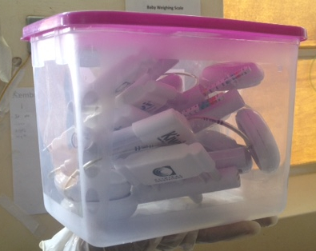

**Note on the use of Cidex-OPA**

Read the instructions from the manufacturer carefully. After pouring Cidex-OPA from the original container, it may be used for 14 days. The solution in the container can be kept for 75 days. Use test strips to test of the Cidex-OPA is still active.

If Cidex is used instead of Cidex-OPA, sterilisation time might be longer, check instructions from manufacturer!

**Quality control**

It is advisable to take regular swabs from the sterilized Kiwi vacuum extractors for culture.